The Big Oak Theatre
and Sunset Singers present:
“THE SUGAR PLUMS”
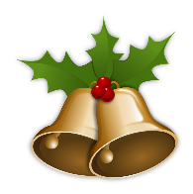
This Photo by Unknown Author is licensed under CC BY-NC
Festive Holiday Show
Holiday music with a 50's flair, sung by a trio of girls so sweet they'll make your holiday season burst with joy!
$28 General, $25 Groups and Seniors.
Saturday, Dec 14, 3 PM
Sunday Dec 15, 3 PM
Big Oak Theatre 22200 Chatsworth St., Chatsworth, Ca 91311
Reserve: 818 998 0185 or Avenueact1@att.net

