**Avenue Act I* and BIG OAK THEATRE Presents:**

**www.BigOakTheatre.com**

***“Scrooge, The Musical”***

**December 2, 3, 9, 10, 16, 17, 2017 (3 PM)**

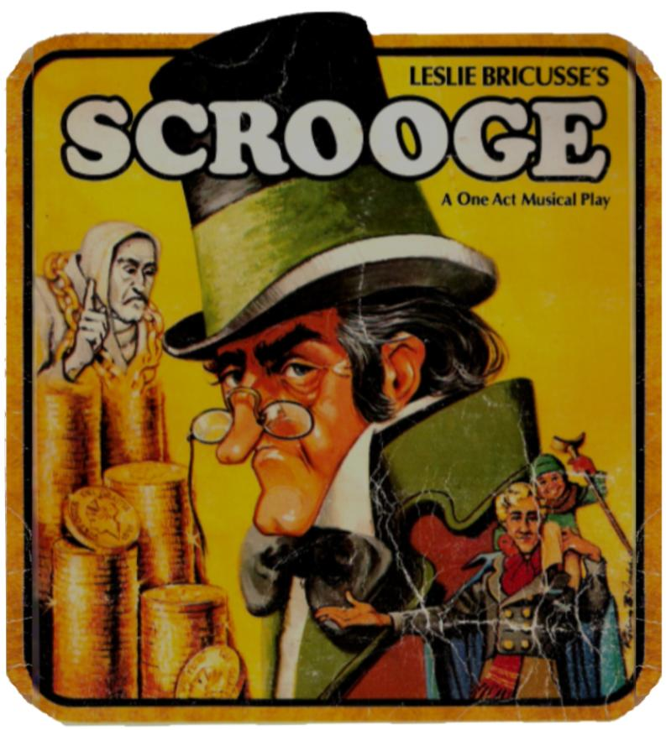

Enjoy **Festive Holiday Music before the Play**

And ***Holiday Treat*** after the Play **!**

**$22 Donation all tickets**

: **Address: Big Oak Theatre, 22200 Chatsworth St., Chatsworth, Ca.**

**Reservations: e mail:** [**Avenueact1@att.net**](mailto:Avenueact1@att.net) **Info: 818 998 0185**

**\*Avenue Act 1 is a 501c3 not for profit theatrical organization**

**MC900383142[1]**